Title in capital letters
AUTHOR A* And AUTHOR B**
^{*)} University A, Country A
**) University B, Country B
E-mail: name@university.edu

A short abstract goes here which outlines the article content. A Book of Abstracts will be available at the Conference, so there is no need to recapitulate it in detail here. A brief description, only. This is written in PTEE Abstract style.
Keywords: two or three keywords go here.
Introduction
All paragraphs use a single interline. The font height is 12 points for the article content. The text is justified. The paragraphs are indented by a quarter of an inch. This is the PTEE body text style. When plots, figures or pictures are presented, PTEE figure style should be used for implementing the picture itself and the figure caption should use PTEE caption style.
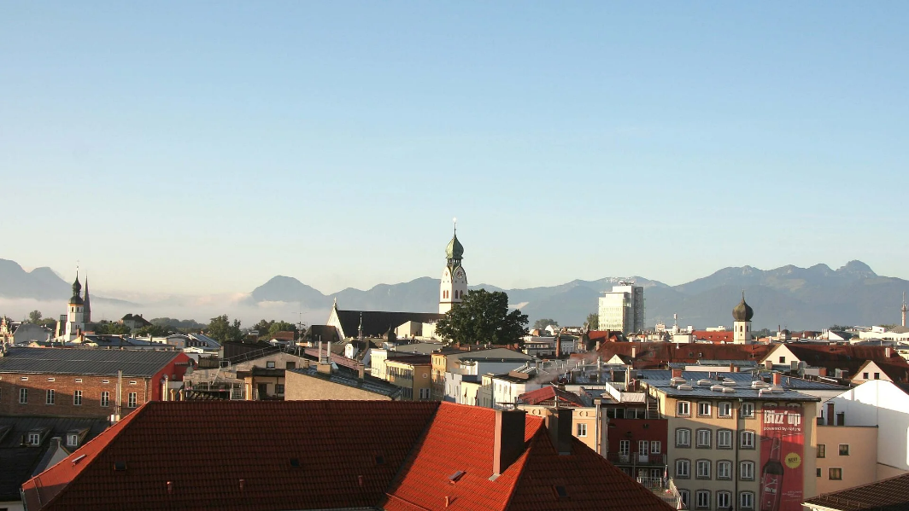
Fig.1. Rosenheim and the Alps.
All references should be numbered consecutively in square brackets [1] and listed at the end of the article. Numerical data can be organized in tables and each table should have the table caption (in the PTEE table caption style).
Table 1. Numerical data for the histogram.
1 | 2 | 3 | 4
A | B | C | D
development
The section titles are in capital letters and use the PTEE Chapter title style. All the styles are named to suggest what they are for. The style names to be used start with PTEE….
Equations should be numbered consecutively. They use PTEE equation style:
$E=mc^{2}$ (1)
This document is to help authors to prepare effectively an article, simply by substituting the existing fragments with a new content and deleting unnecessary ones. The length of the article including all graphs, tables and references should not exceed 8 pages. The article when ready should be sent to ptee2024@th-rosenheim.de
Conclusions
The conference contribution must contain results that were not presented earlier (as a whole) or published elsewhere. In the case of any question concerning manuscripts do not hesitate to contact the Organizers via ptee2024@th-rosenheim.de
References
- The reference (please, keep one style throughout all references)

